Assignment – 1

- Types of Printers, Scanners, and Webcams:
Device | Type | Real-Life Use Case
Printer | Inkjet Printer | Printing college assignments and color photos
Printer | Laser Printer | Printing office documents in large quantities
Printer | 3D Printer | Creating 3D models and prototypes
Scanner | Flatbed Scanner | Scanning certificates and documents
Scanner | Sheet-fed Scanner | Scanning multiple pages quickly in an office
Webcam | Built-in Webcam | Attending online classes or video meetings
Webcam | External USB Webcam | Video conferencing and online interviews

- Labeled Diagram: Home Printer Connected to Laptop:

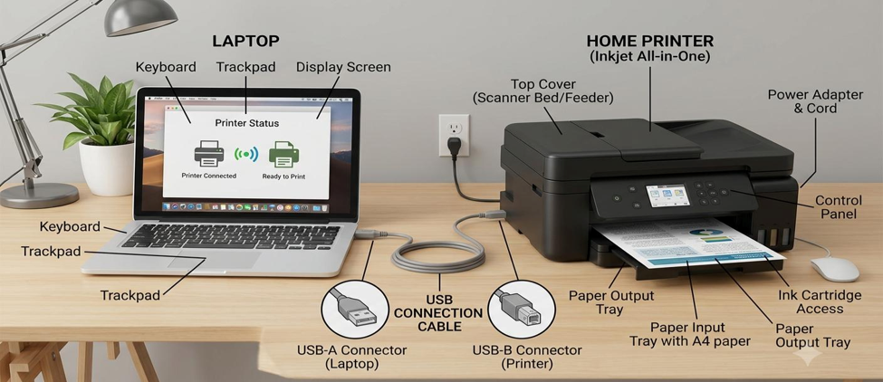

- Connection Interfaces Used by Peripherals:

Connection Interface | Advantage | Disadvantage
USB | Fast and reliable connection | Requires a physical cable
Wi-Fi | Wireless and convenient; multiple devices can connect | Requires Wi-Fi/network setup
Bluetooth | Wireless and easy for short-distance connections | Short range and generally slower than USB

- Steps to Connect a Printer to a Computer:
Device selected: Home Printer
Steps:
- Place the printer near the laptop or computer and connect its power cable.
- Turn on the printer using the power button.
- Make sure the printer supports Wi-Fi and connect it to the home Wi-Fi network using the printer’s display/settings.
- On the laptop, open Settings → Bluetooth & devices → Printers & scanners.
- Click Add device.
- Select the printer from the list of available printers.
- Follow the on-screen instructions to install the required printer driver/software, if needed.
- Set the printer as the default printer if required.
- Open a document and select Print.
- Select the connected printer and click Print to test the connection.
Connection method used: Wi-Fi
Main advantage: No USB cable is required, and multiple devices on the same network can use the printer.

